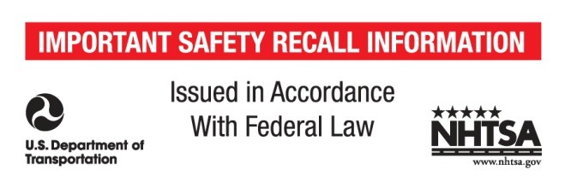

ATR#

Date:
Please select one of the following options: Customer Unit:X Dealer Demo/Display Stock:
** For New/Unopened Inventory: Contact your Alpine Sales Rep
Please fill in the following information where applicable:
Dealer Information:
Dealer Name:
Account#:
Ship to Address:
City / State / Zip:
Telephone: E-Mail Address:
Customer Information:
Customer Name:
Address:
City / State / Zip:
Telephone: E-Mail Address:

PDR-F50 Quantity PDR-M65 Quantity PDR-V75 Quantity
Serial Number: Serial Number: Serial Number:

What should I do?
To request a return number please fill out and send to alpinecustserv@alpine-usa.com or call 800-832-4101 to request return number.
After receiving notification from Alpine:
- Include a copy of the form with the Return number in the package
- Package the product securely to avoid damage during transit
- Make sure your name, return address and phone number are correct
- Please mark your return number clearly on your package
- Contact Alpine for a Call Tag for product pick up

