**Sharing is Caring User’s Manual**

**Share and Enjoy**

**Music, Video, and Photo**

**from**

**Connected Devices**

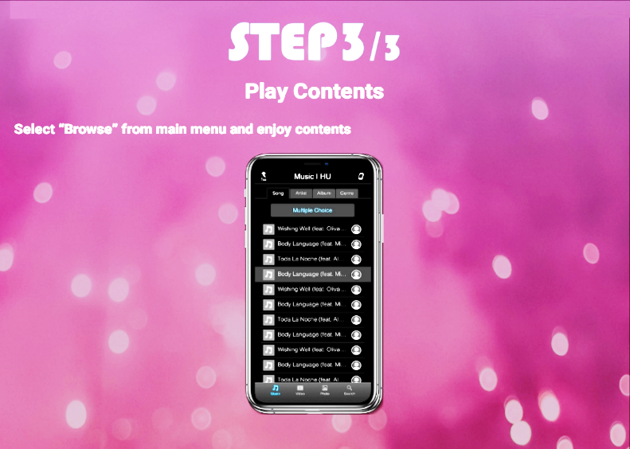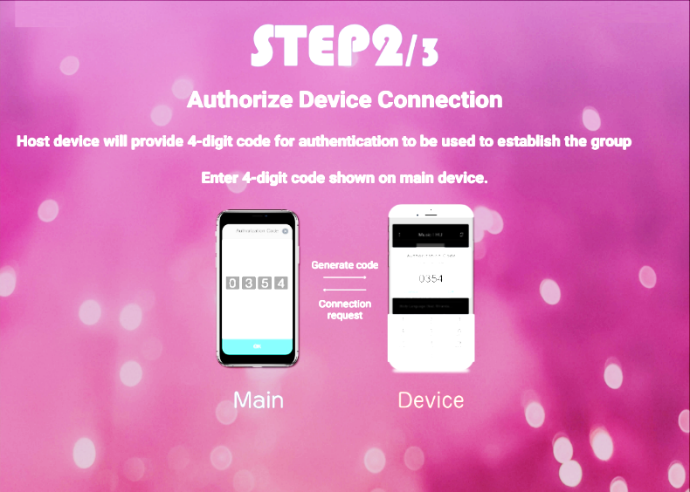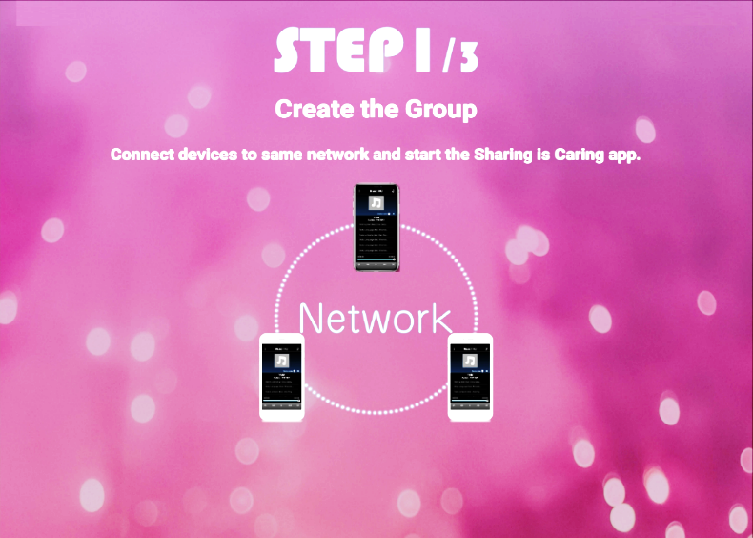

# Contents

**[PRECAUTIONS](#_PRECAUTIONS________________________)**  [ACCOUNT TERMS AND CONDITIONS....................................2](#_PRECAUTIONS________________________)

Privacy Policy (effective since May 7th, 2020) ............................5

**[Operating Instructions](#_Operating_Instructions)**

**[Getting Started](#_Getting_Started___________)**

[App Operating Environment......................................................6](#_App_operating_environment)

[Launch the Application .............................................................6](#_Launch_the_Application)

Establishing Connections Between Devices..[............................6](#_Authenticate_connections_between)

**[Common Operation](#_Common_Operation_______)**

[About Main Menu .....................................................................8](#_About_Main_Menu)

[Switching Contents....................................................................8](#_Switching_Contents)

[Switching Main Device ............................................................](#_Switching_Main_Device) 9

[Choose a Device to Share ..........................................................](#_Choose_a_device)9

**[Music](#_Music___________________)**

[■Display Example for Music Playback Screen ....................10](#_■Display_example_for)

[■Display Example for Music List Screen .......................10](#_■Music_Playback_Screen)

[Playback ...................................................................................11](#_Playback)

[Repeat Play ..............................................................................11](#_Repeat_Play)

[Shuffle Play .............................................................................11](#_Shuffle_Play)

[Share Content ..........................................................................11](#_Share_content)

[Multiple Choice .......................................................................12](#_Multiple_Choice)

[Song/Artist/Album Name Search ............................................12](#_Song/Artist/Album_Name_Search)

**[Video](#_Video_(My_Phone)) (“My Phone”)**

[■Display Example for Video Playback Screen .............1](#_Video_(\“My_Phone\”)_______)3

[■Display Example for Video List Screen .......................1](#_Video_(My_Phone))3

[Playback ...................................................................................14](#_Playback_1)

[Repeat Play ..............................................................................14](#_Repeat_Play)

[Shuffle Play .............................................................................14](#_Shuffle_Play_1)

[Share Content ..........................................................................14](#_Share_content)

[Multiple Choice .......................................................................14](#_Multiple_Choice_1)

[Video Name Search .................................................................15](#_Video_Name_Search)

**[Photo6](#_■Display_example_for_1)**

[■Display Example for Photo List Screen ..............................16](#_■Display_example_for_1)

[■Display Example for Photo Full Screen .............................16](#_■Display_example_for_1)

[See Photo..................................................................................16](#_See_Photo)

[Slide Show................................................................................16](#_Slide_Show)

**[Settings](#_Settings__________________1)**

[Share Setting ............................................................................17](#_Share_Setting)

[Device Setting ..........................................................................17](#_Device_Setting)

**[INFORMATION](#INFORMATION)**

[About Application ........................................................................18](#INFORMATION)

FAQ ([In Case of Difficulty) .........................................................18](#_When_the_Devices)

FAQ ([If this Message Appears) ....................................................19](#_Please_Check_Wi-Fi)

[Notice of Support .........................................................................19](#_Media_Player_Failed)

# **PRECAUTIONS\_\_\_**\_\_\_\_\_\_\_\_\_\_\_\_\_\_\_\_\_\_\_\_\_\_\_\_\_\_\_\_\_\_\_\_\_\_\_

ACCOUNT TERMS AND CONDITIONS

PLEASE READ THESE TERMS AND CONDITIONS CAREFULLY BEFORE SETTING UP YOUR ACCOUNT. IF YOU DO NOT AGREE TO THE TERMS, DO NOT CLICK <CONTINUE> AND DO NOT CREATE AN ACCOUNT.

In particular, please note that: (1) disputes between us will be settled by binding arbitration and you are giving up your right to go to court, and (2) your device software may be automatically updated.

1. **Definition**

**“S.i.C. Terms” means this Sharing is Caring Account Terms and Conditions and other related terms including the Privacy Policy.**

**“Contents Provider(s)” means** a provider of Entertainment.

“**Entertainment**” means any movies, television shows, music and/or other audio or visual materials.

“**Privacy Policy**” means the Service Provider’s privacy policy, available at the Service Provider’s website (<https://www.the-sharing-is-caring.com/Privacy.html>)("**Privacy Policy**")

**“Service Provider” means** Alpine Electronics of America, Inc..

**“S.i.C.” means this Sharing is Caring system.**

"**S.i.C. Service**" "**our service**" or "**the service**" means the service provided by the Service Provider for both locally stored and streaming Entertainment, including all features and functionalities and user interfaces associated with the service.

1. **Overview**

The S.i.C. Service shall be given to an end user only by the Service Provider. An end user online profile is required to activate your S.i.C. service. Registration gives you access to the basic features provided by the S.i.C. application. In order to enjoy streaming services, you will need to have an established service agreement with the Contents Provider separately. After your S.i.C. account is created, you can link your device to your account. When you link the device, you may be asked to agree to a separate end user license agreement.

The S.i.C. Terms governs your Account, your use of platform and services, and excludes subscriptions, purchases and rentals made with individual Contents Providers.

In addition, if you choose to access any **Entertainment** through S.i.C., you will need to also agree to the terms of service of the Contents Providers whose Entertainment you choose to access. The terms of service of such Contents Providers may impose additional requirements or provide them the right to cancel or suspend their service to you.

You agree to be required to comply with any applicable laws and regulations including import/export laws and regulations when you apply to, use or enjoy the S.i.C. service or application.

1. **Acceptance of S.i.C. Terms**

By setting up a S.i.C. Account or using the S.i.C. application, you are agreeing to be bound by these S.i.C. Terms.

1. **Changes to S.i.C. Terms**

The Service Provider may amend the S.i.C. Terms at any time in its discretion. Such amendments shall be effective immediately upon posting of the amended S.i.C. Terms via your S.i.C. Account, the device linked to your S.i.C. Account or the Service Provider’s website, whichever occurs first. You agree to provide accurate and complete information when you establish your S.i.C. Account, and you agree to promptly update your account information (including contact information) to keep it accurate and complete. You can do this at any time by signing in to your S.i.C. Account. Following the posting or notice by any of the methods described above, continued use of any device linked to your S.i.C. Account or your S.i.C. Account means you accept and agree to the amended S.i.C. Terms. If you do not agree to the amended S.i.C. Terms, S.i.C. may not be able to provide updates, upgrades or enhancements to your devices, and you may not be able to continue using your devices or S.i.C. Account.

**5. Privacy Policy and Use of Data**

The Privacy Policy explains Service Provider's policies regarding the collection, use, transmission and disclosure of information provided by or collected from you, including via your S.i.C. Account, and/or the devices linked to it. BY AGREEING TO BE BOUND BY THESE S.i.C. TERMS, YOU ARE AGREEING THAT YOU HAVE READ AND UNDERSTOOD THE COLLECTION, USE, TRANSMISSION AND DISCLOSURE OF YOUR INFORMATION OR DATA AS DESCRIBED IN THE PRIVACY POLICY (AND AS AMENDED FROM TIME TO TIME). You should review the Privacy Policy before establishing a S.i.C. Account and before linking any device to it. The policies and other content may be changed by Service Provider in its sole discretion, without notice to you.

**6. S.i.C.** **Account**

You will need to supply certain information. You agree that all personal information or other information you provide to us will be (i) accurate, current, and complete; (ii) promptly updated when there is a change; and (iii) your own information and not that of another individual. If you provide any information that is untrue, inaccurate or incomplete, or we have reasons to suspect that such information is untrue, inaccurate or incomplete, we retain the right to suspend or terminate the S.i.C. Service and any S.i.C. Account you establish and/or to refuse any or all current or future use of the S.i.C. Account or any devices linked thereto.

Your S.i.C. Account credentials are for your personal use only. Do not reveal your S.i.C. Account information to anyone. You acknowledge and agree that you are solely responsible for maintaining the confidentiality of your S.i.C. Account, login ID and password, and for all activities that occur on or through your S.i.C. Account. You agree to immediately notify the Service Provider of any unauthorized use of your S.i.C. Account, or any other security breach involving your S.i.C. Account. You agree that the Service Provider will not be responsible for any losses arising out of any unauthorized use of your S.i.C. Account.

**7. Fees and Charges**

All fees required to access Entertainment will be charged to your payment method on file with the Contents Provider directly.

**8. S.i.C.** **Service; Entertainment Availability**

The locally stored media (e.g., music, video, and/or picture stored on the device) and streaming content sharing operated and viewed through the S.i.C. application are solely for your personal and non-commercial enjoyment. Such usage is protected by copyright or other intellectual property laws and treaties, and is subject to the terms of use provided by the respective Contents Provider. Such Terms of Use do not grant you the right to copy, distribute, prepare derivative works or publicly display such content, except for locally stored media personally created by the user. You may not engage in or facilitate unauthorized access to or use of the content.

You only have access to locally stored media and streaming content that have been authorized for the country with respect to which you have registered your S.i.C. Account, and such contents will vary by geographic location or country. S.i.C. and/or its Contents Provider may use technologies to verify your geographic location, and you may not be able to access any streaming contents outside of the country or location authorized by S.i.C. or such Contents Provider. You understand that the display quality of the content being streamed by your device may vary from device to device, and may be affected by many factors, including your internet speed and your location. From time to time, S.i.C. may temporarily suspend your account access or our service for maintenance and repair. Access to the locally stored media device-to-device sharing does not necessitate internet connectivity; however, streaming content sharing requires internet connectivity. Depending on your contract with your data package provider, you may incur additional data charges from your provider when you utilize the streaming content sharing.

S.i.C. may add or remove Contents Providers from time to time without notice to you. Contents Providers may also add or remove contents from their services from time to time without notice to you or S.i.C.. S.i.C. reserves the right to remove or restrict, from your device, access to any streaming content if it has reason to believe that the device linked to your S.i.C. application is stolen, hacked or compromised, or that the streaming content or associated account is not properly authorized or licensed, violates any law, or has been offered by a streaming content in violation of any agreement itself and its partners from what it believes to be fraudulent or illegal activity. You are responsible for ensuring that any age-restricted streaming content is not viewed by any person not meeting the applicable age limits, as specified by law, regulation or the Contents Provider. Similar restriction also applies to unlawful usage of the S.i.C. application while operating motor vehicle; governing State and Federal law and regulation must be abided. SERVICE PROVIDER IS NOT RESPONSIBLE AND LIABLE FOR ANY INCIDENT CAUSED BY ANY USE OF S.i.C. APPLICATION OR YOUR DEVICE WHILE OPERATING A MOTOR VEHICLE OR DOING ANY ACTIVITY.

**9. Service Updates**

The Service Provider reserves the right to AUTOMATICALLY update the S.i.C. SERVICE, including BUG FIXES AND UPDATES, CHANGES IN THE USER INTERFACE OR HOW YOU ACCESS CONTENT, AND OTHER CHANGES THAT MAY add, ALTER or REMOVE functionalities and features. You acknowledge that these updates may happen automatically in the background at any time (and that they shall not be disabled). You understand that these updates are necessary to maintain compatibility with other updates to our products or services and may be required for security reasons. By using the S.i.C. SERVICE, you hereby AGREE to receive such updates.

**10. Warranty Disclaimer; Limitation on Liability**

TO THE MAXIMUM EXTENT PERMITTED BY APPLICABLE LAW:

(A) THE S.i.C. SERVICE AND YOUR S.i.C. ACCOUNT ARE PROVIDED "AS IS" AND "AS AVAILABLE" WITH ALL FAULTS AND WITHOUT WARRANTY OF ANY KIND. THE SERVICE PROVIDER DOES NOT GUARANTEE, REPRESENT, OR WARRANT THAT THE S.i.C. SERVICE OR THE USE OF S.i.C. ACCOUNT WILL BE: (I) UNINTERRUPTED, SECURE, VIRUS-FREE OR ERROR-FREE, OR (II) FREE FROM ATTACK OR SECURITY INTRUSION;

(B) IN NO EVENT SHALL THE SERVICE PROVIDER, ITS DIRECTORS, OFFICERS OR EMPLOYEES BE LIABLE TO YOU FOR PERSONAL INJURY OR PROPERTY DAMAGE, OR ANY SPECIAL, INCIDENTAL, EXEMPLARY, PUNITIVE, INDIRECT OR CONSEQUENTIAL DAMAGES OF ANY KIND ARISING OUT OF YOUR USE OF THE S.i.C. SERVICE OR S.i.C. ACCOUNT, HOWEVER CAUSED (INCLUDING NEGLIGENCE); AND

(C) YOU AGREE THAT THE TOTAL CUMULATIVE LIABILITY OF THE SERVICE PROVIDER, ITS DIRECTORS, OFFICERS AND EMPLOYEES UNDER THIS S.i.C. TERMS, INCLUDING LIABIILTY RELATING TO THE S.i.C. SERVICE, YOUR S.i.C. ACCOUNT, YOUR INFORMATION AND ALL DEVICES LINKED TO YOUR S.i.C. ACCOUNT, SHALL NOT EXCEED THE TOTAL PURCHASE PRICE YOU PAID FOR S.i.C. APPLICATION LINKED TO YOUR S.i.C. ACCOUNT. THE FOREGOING LIMITATIONS SHALL APPLY EVEN IF THE REMEDY PROVIDED HEREIN FAILS ITS ESSENTIAL PURPOSE AND EVEN IF S.i.C. DIRECTORS, OFFICERS OR EMPLOYEES HAVE BEEN ADVISED OF THE POSSIBILITY OF SUCH LIABILITY.

IF CERTAIN JURISDICTION DOES NOT PARTIALLY OR WHOLLY ALLOW EXCLUSIONS OF CERTAIN WARRANTIES OR LIMITATOINS OF LIABILITY FOR CERTAIN TYPES OF DAMAGES, THE ABOVE EXCLUSION OR THE ABOVE LIMITATIONS IN THIS SECTION MAY NOT APPLY TO YOU TO THE EXTENT THAT SUCH JURISDICTION DOES NOT ALLOW. NOTHING IN THESE TERMS AND CONDITIONS SHALL AFFECT ANY NON-WAIVABLE STATUTORY RIGHTS THAT APPLY TO YOU.

**11. Choice of Law; Dispute Resolution**

(A)  **Governing Law.**  You agree that these S.i.C. Terms and any dispute of any sort that might arise between you and the Service Provider shall be governed by the laws of the State of Michigan, without regard to any conflict of laws principles that may provide the application of the law of another jurisdiction; and:

(B)  **Dispute Resolution.**  Any dispute or claim related to the S.i.C. Service between you and the Service Provider shall be will be resolved by one arbitrator, in accordance with the Commercial Arbitration Rules of the American Arbitration Association (“AAA”) then in effect in the State of Michigan and will be held in the State of Michigan. **You and** the Service Provider **agree that any and all claims shall be finally settled by binding arbitration.** Judgment upon the award rendered by the arbitrator(s) may be entered in any court having jurisdiction thereof.

You may learn more about the AAA and its rules for arbitration by visiting www.adr.org or by calling 800-778-7879. Since these Terms and Conditions concern a transaction in interstate or international commerce, the Federal Arbitration Act will apply. The arbitrator's award shall be binding on you and the Service Provider, and may be entered in any court of competent jurisdiction.

You and the Service Provider agree that any dispute resolution proceedings will be conducted only on an individual basis and not in a class, consolidated or representative action. **Also, the arbitrator may award relief (including monetary, injunctive or declaratory relief) only on an individual basis and may not award any form of consolidated, representative or class-wide relief.** If for any reason a claim proceeds in court rather than in arbitration, you and the Service Provider waive any right to a jury trial. Notwithstanding any provision in these terms to the contrary, if the class-action waiver in this provision is deemed invalid or unenforceable, or if an arbitration is allowed to proceed on a class basis, then neither you nor the Service Provider are entitled to arbitrate the claims.

(C) **Exclusions.** This agreement to arbitrate does not apply to any claim in which a party is attempting to protect its intellectual property rights (such as its patent, copyright, trademark, trade secret, or moral rights, but not including its privacy or publicity rights).

(D) **Jurisdiction.** If the agreement to arbitrate in this provision is found to be invalid, unenforceable or inapplicable to a given claim, then any and all proceedings to resolve such claim must be brought exclusively at federal or state court in Oakland county, Michigan, USA. Also, if the arbitrator awards injunctive relief against either of us, that party may seek judicial review of the arbitrator's decision on that issue in these courts. You hereby irrevocably consent to the exclusive jurisdiction and venue of such courts.

(E) **30-Day Right to Opt Out.** IF YOU DO NOT WISH TO BE BOUND BY THE BINDING ARBITRATION AGREEMENT AND CLASS ACTION WAIVER, THEN: (1) you must notify the Service Provider in writing within thirty (30) days after the date you create your S.i.C. Account; (2) your written notification must be mailed to the Service Provider at the address stated in Service Provider’s document or website, Attn: Legal Department; and (3) your written notification must include (a) your name, (b) your address, (c) the date you purchased the product, and (d) a clear statement that you wish to opt out of the binding arbitration agreement and class action waiver.

(F) **Changes.** Notwithstanding any provision in this Agreement to the contrary, you agree that, if the Service Provider seeks to delete or materially modify the agreement to arbitrate described herein, any such deletion or modification will not apply to any individual claim of which you have notified the Service Provider prior to such modification.

**12. Miscellaneous**

The Service Provider may transfer its rights and obligations under this S.i.C. Terms to another organization. You may only transfer your rights or your obligations under this S.i.C. Terms to another person if the Service Provider agrees in writing. These S.i.C. Terms are between you and the Service Provider. No other person shall have any rights to enforce these Terms. Each of the paragraphs of these S.i.C. Terms operates separately. If any court or relevant authority decides that any of them are unlawful, the remaining paragraphs will remain in full force and effect. If the Service Provider fails to insist that you perform any of your obligations under these S.i.C. Terms, or if the Service Provider does not enforce its rights against you, or if the Service Provider delays in doing so, that will not mean that the Service Provider has waived its rights against you, or that you do not have to comply with those obligations. If the Service Provider does waive a default by you, the Service Provider will only do so in writing, but that will not mean that the Service Provider will automatically waive any later default by you.

**13. Contact Information**

If you wish to contact Service Provider, please send your correspondence by mail to : 4312 Tuller Rd, Dublin, OH 43017, USA or by email to [support@the-sharing-is-caring.com](mailto:support@the-sharing-is-caring.com).

If the Service Provider needs to contact you, the Service Provider will do so by e-mail to the e-mail address you provide under your S.i.C. Account.

Last Updated: May 7th, 2020

Privacy Policy (effective since May 7th, 2020)

When you use an Application provided by Sharing is Caring App ("S.i.C.") certain information about you and your usage of the App is collected.

1. **Controller and Data Protection Officer**

The Controller of the personal data you provide is Alpine Electronics of America, Inc. located at 1500 Atlantic Boulevard, Auburn Hills, Michigan 48326, USA (“Service Provider”).

**\_\_\_\_\_\_\_\_\_\_**

1. **What Type Of Information Is Collected**

We may collect the following information

through your use of S.i.C.:

- Your email address (may be obtained when you establish an account through S.i.C.)

- Data pertaining to your use of the App such as:

* Connected network type.
* Connected device numbers.
* Connected device type.
* Connected device’s locally stored data file type and quantity.
* Connected device’s time and length of use.
* Location and time of use.
* Shared contents type and quantity.
* Peripheral unit connectivity.
* General operation and history.

**\_\_\_\_\_\_\_\_\_\_\_\_\_**

1. **What S.i.C. Does With Information Collected and the Legal Basis for its Use**

With your consent (Opt-in option), S.i.C. enables Firebase Analytics tools to aid in the understanding of S.i.C. usage which assists in performance optimization.

We use this information to manage the Service Provider’s service with precision, to monitor S.i.C. activity and to develop ideas for marketing research and other marketing purposes, which may include sharing it with the Service Provider’s affiliates for the purpose of improving the service.

Information you provide which the Service Provider may use without your explicit consent is limited to that information necessary to provide you with the services you are requesting.

**\_\_\_\_\_\_\_**

1. **Who Receives your Data**

We do not share personal information

with third parties outside of the Service Provider

unless one of the following

circumstances applies:

- With your consent

In cases where we seek and receive your prior consent, we may share personal information with third parties outside of the Service Provider.

- For legal reasons

In cases where the Service Provider is compelled by law, legal process, litigation, and/or requests from public and governmental authorities within or outside your country of residence, to disclose information collected through the S.i.C..

* For technical reasons

Information collected about you through S.i.C. will be stored on secure servers hosted or managed by the Service Provider, its affiliates or subcontractors. Because the Service Provider is committed to protecting your privacy, neither the Service Provider, its affiliates nor subcontractors engage in the practice of sharing, trading or selling personal information to third parties.

* The affiliates which may currently host or manage the secure servers to store the above information are:

1. Alps Alpine Co., Ltd. (the Service Provider’s parent company)

* The subcontractors currently used by the Service Provider are:

1.   Google Firebase

**\_\_\_\_\_\_\_**

1. **Notification About Changes To This Policy**

By using this App, you agree to the terms of this privacy policy. We may alter this policy at any time. If changes are made to this policy, we will provide the new language of the privacy policy within S.i.C.. Also, version updates for S.i.C. will contain the then—current Privacy Policy.

**\_\_\_\_\_\_\_**

1. **Your Rights**

Please contact us via e-mail [support@the-sharing-is-caring.com](mailto:support@the-sharing-is-caring.com)

to review the

information collected through your use of S.i.C.. We will take identification procedures and accommodate your request within reasonable bounds.

Through the e-mail, request “Your Privacy Rights” information.

If you wish to withdraw your consent, please contact the Service Provider. The Service Provider will take all reasonable measures to ensure that your request is met.

If a complaint or dispute cannot be resolved through our internal process, the Service Provider agrees to dispute resolution provided in the **Sharing is Caring Account Terms and Conditions**.

1. **Integrity of Personal Information on Your Device**

Some third party apps do keep track of your browsing activities when they serve you content, which enables them to tailor what they present to you. Third parties cannot collect any other personally identifiable information from S.i.C. unless you provide it to them directly.

1. **Note About Storage of Information Collected**

Information collected through S.i.C. will be stored and processed on secure Service Provider’s, affiliate’s or subcontractor’s servers in the United States of America or Japan.

The Service Provider will take all steps reasonably necessary to ensure that collected information is stored and processed securely and in accordance with all applicable laws.

1. **CALIFORNIA CONSUMER PRIVACY ACT (CCPA)**

Under California law, a S.i.C. user who are residents of California have the right to request that we disclose certain information to you about our collection and use of your personal information over the past twelve months under the California Consumer Privacy Act (CCPA). Also, such user has the right to request that we delete any of your personal information that we collected from you and retained, subject to certain exceptions. Once the Service Provider receives and verify such user’s request, the Service Provider will delete your personal information from our records, unless an exception applies. If you are a California resident who wishes to make such a request, please call us toll-free at 1-800-257-4631 or make a **[privacy request](https://kb.alpine-usa.com/contact.php" \t "_blank)** through our online form.

# Operating Instructions

## Getting Started\_\_\_\_\_\_\_\_\_\_\_

### App Operating Environment

* Wi-Fi supports Wi-Fi standards with communication speeds of 10 Mbps or more.
* For information about the functions of each device, refer to the user's guide for each device.
* The supported OS versions are as follows:

*We cannot guarantee the operation and performance of the App with OS software version prior to:*

Android OS : 7.0

iOS : 12

iPad OS : 13

* The size of the App is 62MB.Your device needs to have enough free space.

### Launch the Application

**1 Turn on the Wi-Fi setting of the device.**

**2 Touch the installed S.i.C icon to launch the Application.**

**3 Read the App's terms and conditions, check "I agree" and proceed.**

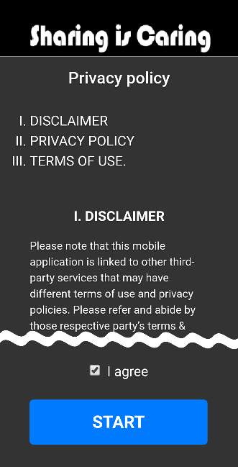**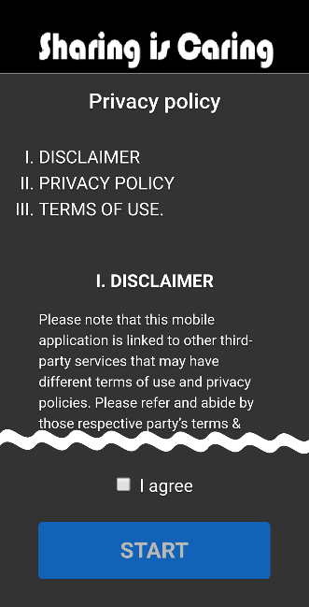**

➡

* The terms and conditions is only displayed when the App is first launched.  [*See "PRECAUTIONS"*](#_PRECAUTIONS________________________)
* Once you checked "I Agree" and proceded to next step, you have accepted the Terms of Use.

**4 Access Permissions.**

* Storage: Access to media(music, video) files and photos on your device.

Access media files in your device to share contents.

If you don't check "Allow", the content on your device will not be shared.You can access the contents of other devices that have authorized connections to the main device and granted storage access privileges.

●Location Information: Access to your device's location.

Access to the location information of your device to verify SSID information on your network connection.If you don't allow, you won't be able to see which network your device is connected to.

Note: The permission is checked the first time the App is started. If you want to check or change your settings, tap "Apps and Notifications" from your device's settings menu and select “Sharing is Caring". You can check and change storage and location authorization from "App Information" --> "Permissions".

1. **App Tutorial.**

[*See "Cover Page."*](#_top)

**If you accept the Terms & Conditions of this App and grant permission, it will then be available.**

**This App can share contents between devices that are authenticated.**

*[See "Establishing Connections Between Devices"](#_Authenticate_connections_between)*

**To protect your privacy, the initial setting for content share is set to "Not Share". It is highly recommended that you change your content share settings after you've authenticated your connection with the other device.** *[See “Share Setting”](#_Share_Setting)*

### Establishing Connections Between Devices

This Application can connect up to (3) devices connected to the same Wi-Fi.

To establish a connected network, you need to set one device as the Main device. *[See "Switching Main Device"](#_Switching_Main_Device)*

**1 Touch [Device List] icon on top right corner of Main device.**

*If [Device List] icon is hidden, show Browse screen.*

The display shows the Device List screen.

**■Main device**

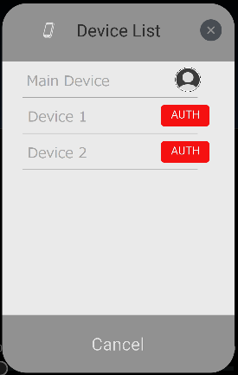

A list of devices with Apps installed and launched undere the same Wi-Fi network will be listed.



: Non-Authenticated.

**2 Select the device you wish to connect to the Main device.**

The Main device will display the 4-digit authentication code, and the device you had selected will display the authentication code input screen to input 4-digit code.

For security reasons, the authentication code will change each time.

**3 Input the 4-digit authentication code on the device you had selected and hit “Share”.**

**■Main device ■Selected Device**

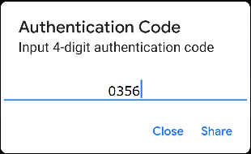**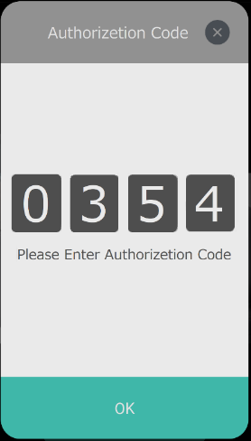**

* If you want to stop authenticating connections to the selected device, close the Device List screen or Authentication Code screen.
* If the selected device wants to stop authenticating the connection to the Main device, close the Authentication Code screen.

**4 Authenticate connections between devices.**

When the connetion is successfully completed, the Main device will change [AUTH] indication to an icon mark, and the connected device will display “Authentication Completed” screen.

**■Main Device ■Connected Device**

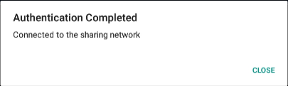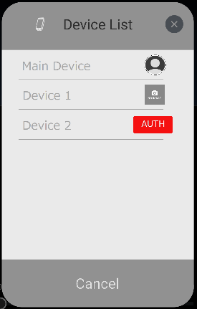

* If you are connecting for the first time, you need to authenticate the connection.
* After the connection is authenticated, it will be automatically connected from the next time.

If the device connections are not successfully completed, do the following operation.

*[See "Devices cannot be connected to each other"](#_When_the_Devices)*

## Common Operation\_\_\_\_\_\_\_

### About Main Menu

**Touch [Main Menu] icon on top left corner.**

*If [Main Menu] icon is hidden, touch [Top] icon on top left corner of the Browse screen (Music/Video playlist, Photo screen, Search screen).*

The display shows the Main Menu screen.

**■Playback Screen ■Browse Screen**

**(ex. Video Playlist)**

[Main Menu] icon [Top] icon

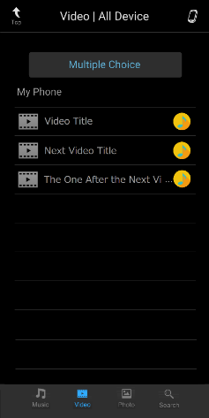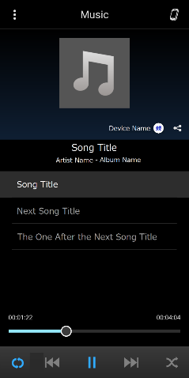

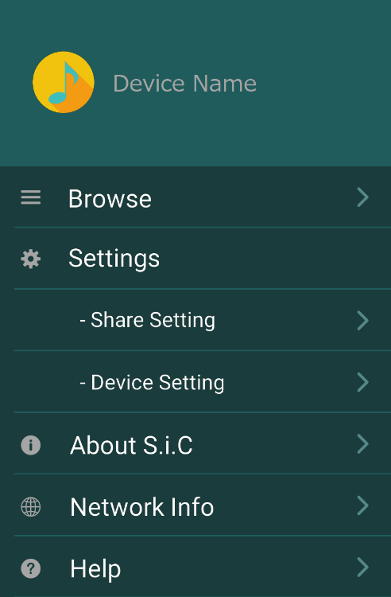**■Main Menu Screen**

* **Browse :** Tap to switch between contents.

Touch to display the music list screen.

Tap the content icon at the bottom of the

music list screen to switch between contents.

[*See "Switching Contents"*](#_Switching_Contents)

* **Settings :** [*See " Settings"*](#_Settings_________________)
* **About S.i.C :** *[See "About](#INFORMATION)* [Application](#INFORMATION)*["](#INFORMATION)*
* **Help :** A simplified usage information. For details, please read this operational instruction.

*[See " In Case of Difficulty "](#_When_the_Devices)*

### Switching Contents

During music or video playback, touch a content icon on the bottom the screen to switch to the desired contents.

**1 Touch [Main Menu] icon on top left corner.**

The display shows the Main Menu screen.

**2 Touch [Browse].**

The display shows the Browse screen.

**3 Touch desired content icon on bottom of the screen.**

Touch the content icon on the bottom of the screen to select between Music, Video, Photo, or Search and select the desired contents.

**■Switching Contents Using the Bottom Banner**



**Music**

Category : Song/Artist/Album/Genre

Supported files : WAV(\*1)/MP3/AIFF(\*2) /Audible(\*2) /Apple Lossless(\*2) /FLAC(\*3)

*Note 1: You may not be able to play on Android devices.*

*Note 2: It can only be played on iOS devices.*

*Note 3: It can only be played on Android devices.*

**Video**

Category : In-device video/external service video(\*)

\*You Tube/NETFLIX/hulu/Amazone prime video

Supported files : m4v (\*1) / mov(\*2) / 3gp / mp4(\*2) / MKV(\*3)

Note 1: Only supported by iOS devices.

Note 2: Only if the video format is h.264 or mpeg4, it can be played on iOS devices.

Note 3: Cannot be played on iOS devices.

**Photo**

Supported files : BMP(\*1) / GIF(\*1) / JPEG / PNG / WebP(\*2) / TIFF(\*3)

Note 1: You may not be able to see on Android devices.

Note 2: You cannot see photos on iOS devices.

Note 3: It is not possible to see on Android devices.

**Search**

Music : Song/Artist/Album

Video : In-device videos and external service videos (You Tube)

*The content you can play depends on the device and the file format of the content.*

### Switching Main Device

To connect devices, only one must be in Main mode and the others must be operating as Device mode.

**1 Touch [Main Menu] icon on top left corner.**

The display shows the Main Menu screen.

**2 Touch [Network Info].**

The display shows the Network Info screen.

**3 Adjust it so that only one device is in Main mode.**

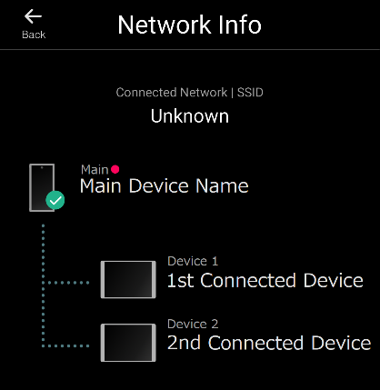**■Network Info Screen**

: Your device

What is Main/Device in operating mode?

* Main mode: Manages devices connected to the same network and shared file information.
* Device mode: Sharing the contents of other devices through a device in Main mode.

### Choose a Device to Share

Select the device you want to share the conents to. Devices must be connected to the same network and authentication steps need to be completed to share the content.

**1 Touch [Device List] icon on top right corner of the Main device.**

*If [Device List] icon is hidden, show Browse screen.*

The display shows the Device List screen.

**2 Touch [Device List] screen.**

The display shows the selectable devices.

**■Device List Screen ■Device List Screen**

**(Selectable)**

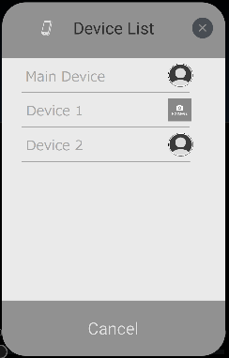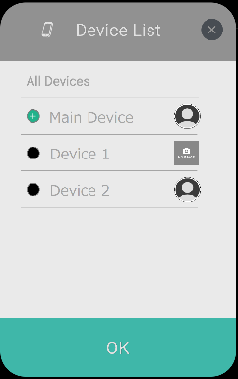

**3 Touch the device to which you want to share on your network.**

**■Device List Screen (Selectable)**



*“All Devices” will select all connected devices.*

 : Selected it.



: Not Selected.

**4 When you select a device, tap OK at the bottom of the screen.**

*If you want to stop changing a device, close the screen.*

## Music\_\_\_\_\_\_\_\_\_\_\_\_\_\_\_\_\_\_\_

### ■Music Playback Screen

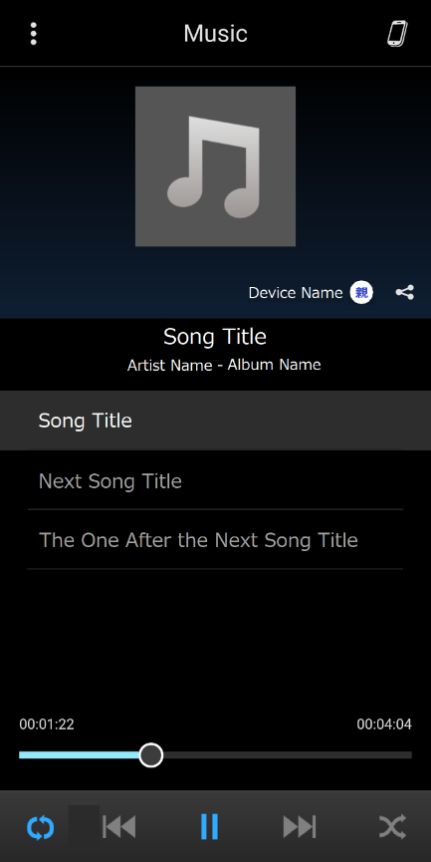

②

③

④

⑤

⑥

⑦

⑧

⑨

⑩

⑪

⑫

⑬

⑭

■Music List Screen

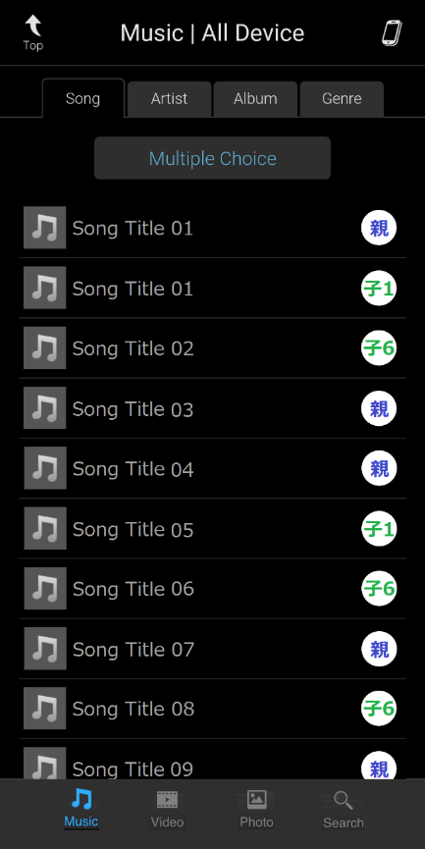

⑮

⑯

⑰

⑱

⑳

⑲

1. [⋮] Main Menu

*This icon is common to all content screens. The display shows the Main Menu screen. Switch contents and set various settings from Main Menu.*

1. Device List

*This icon is common to all content screens. The display shows a list of connected devices. You can choose a device you want to share contents.*

1. Cover Art of Song Being Played
2. Device Name and Device Icon

*Displays the name and icon of the device which is sharing the contents.*

1. Sharing Icon

*This icon is common to all content screens. Shares the playing song to the connected device.*

1. Song Title
2. Artist Name – Album Name
3. Playlist

*Displays a playlist by the category (Song/Artist/Album/Genre).*

1. Playing Time

*Displays the duration of the played song. Slide the bar to change the playback position.*

1. Repeat Play
2. [|<<] Return to the Beginning of Current Song
3. [ || ]/[ > ] Pause/Play
4. [>>|] Skip to the Next Song
5. Shuffle Play
6. Top Icon

*This icon is common to all content screens. The display shows the music playback screen.*

1. Category Tab (Song/Artist/Album/Genre)
2. Multiple Choice
3. Music List
4. Music Icon
5. Search Icon

### Playback

**1 Touch [Main menu] icon on top.**

The display shows the Main Menu screen.

**2 Touch [Browse].**

The display shows the Browse screen.

**3 Touch [Music] icon on bottom.**

The display shows the music list screen.

The list is displayed in ascending alphanumeric order.

**4 Select the desired song from a music list.**

You can select a song from the music list screen.

***Selecting from the list of the Song:***

Touch [Song] tab, display shows the song list.

Select the desired song.

***Selecting from the list of the Artist:***

Touch [Artist] tab, display shows the artist list.

Select the desired artist, display shows the album list of the selected Artist.

Select the desired album.

***Selecting from the list of the Album:***

Touch [Album] tab, display shows the album list.

Select the desired album.

***Selecting from the list of the Genre:***

Touch [Genre] tab, display shows the song list of the selected genre.

Select the desired song.

The display shows the music playback screen.

**5 Touch [|<<] or [>>|] or select the desired song.**

***Returning to the beginning of the current song:***

Touch [|<<]

***Advancing to the beginning of the next song:***

Touch [>>|]

**6 To pause playback, touch [ || ] on bottom banner.**

Touch [>] on bottom banner to start playback.

### Repeat Play

**Touch [Repeat Play] icon on bottom to enable repeat playback.**

The songs will be played repeatedly.

The repeat mode switches every time the icon is touched.

Repeat List→Repeat One→ (Off) → Repeat List



### Shuffle Play

**Touch [Shuffle Play] icon on bottom banner during playback.**

The songs shuffle randomly plays back songs within a playlist (selected category: artist, album, etc.).

The songs within the playlist are played only once until all songs have been played.

Shffle → (Off) → Shuffle

### Share Content

You can only share to the devices you have set to share.

[See “Choose a device to Share”](#_Choose_a_device)

**1 Touch [Share] icon on playback screen during playback.**

The display shows the Content Share window.

**2 Select a device(s) to share the content from the list.**

*If the mark on the left side of the list becomes ☑ from □, it is selected properly.*

*If you want to stop sharing, tap (X) at the top of the screen.*

**3 Touch [Share] button.**

Select the sharing method.

* **Share One** : Share only one content that is playing.
* **Share List** : Share a list of the categories you're playing.

### Multiple Choice

You can select and play multiple contents from the Song/Artist/Album categories.

**1 Touch [Main Menu] icon on top.**

The display shows the Main menu screen.

**2 Touch [Browse].**

The display shows the Browse screen.

**3 Touch [Music] icon on bottom.**

The display shows the music list screen.

The list is displayed in ascending alphanumeric order.

**4 Touch the desired category tab.**

***Selecting from the list of the Song:***

Touch [Song] tab, display shows the song list.

***Selecting from the list of the Artist:***

Touch [Artist] tab, display shows the artist list.

***Selecting from the list of the Album:***

Touch [Album] tab, display shows the album list.

**5 Touch [Multiple Choice].**

The display shows the [Play] and [Cancel] button.

*If you touch [Artist] tab, display shows the [Play] and [Album Choice] and [Cancel] button.*

*Touch [Album Choice] button, display shows the album list of the selected artist.*

**6 Select the desired contents from the list.**

*If the mark on the left side of the list becomes (+), it is selected properly.*

**7 Touch [Play] button.**

The display shows the music playback screen.

*If you want to stop Multiple Choice, touch [Cancel] button.*

### Song/Artist/Album Name Search

**■Search Screen**

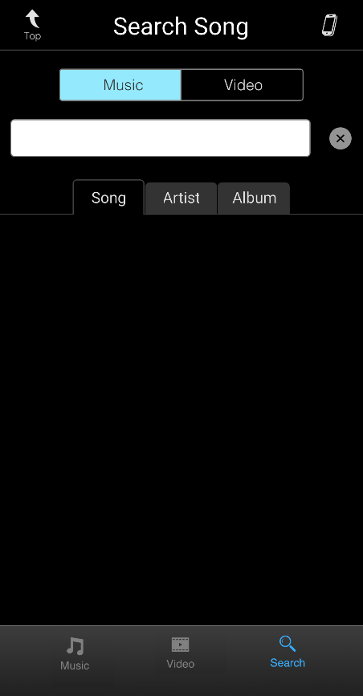

➀

②

③

④

⑤

1. [Music] Button
2. Free Word Search Bar
3. Category Tab
4. Search Result List
5. Search Icon

**1 Touch [Main Menu] icon on top.**

The display shows the Main Menu screen.

**2 Touch [Browse].**

The display shows the Browse screen.

**3 Touch [Search] icon on bottom.**

The display shows the Search screen.

**4 Touch [Music] button on Search screen.**

**5 Enter words to be searched in the bar.**

The display shows search result list.

**6 Touch the desired category tab.**

You can narrow the search results by Song/Artist/Album category.

**7 Select from the search result list.**

The display shows the music playback screen, start playback of the selected content.

## Video (“My Phone”)\_\_\_\_\_\_\_

■Video Playback Screen

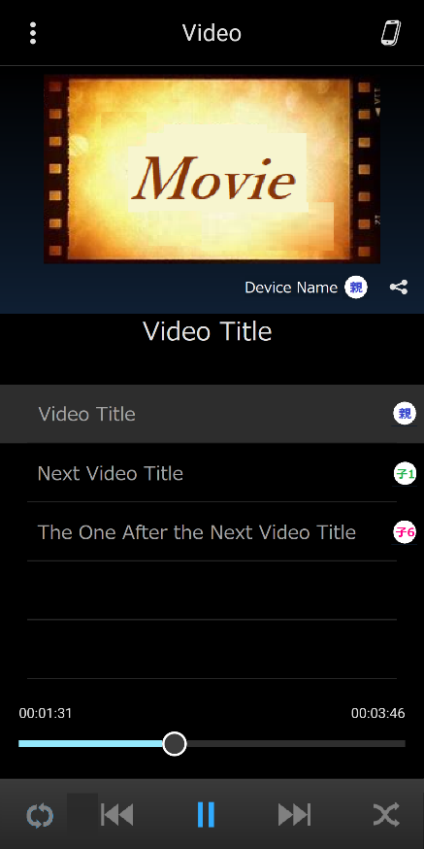

③

④

⑤

⑥

⑦

⑧

⑬

⑫

⑪

⑩

⑨

*Screen orientation changes by turing the device sideway, resutlting in full screen mode.*

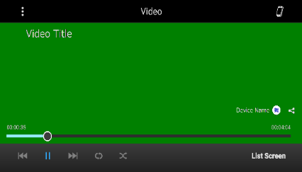

1. [⋮] Main Menu

*This icon is common to all content screens. The display shows the Main Menu screen. Switch contents and set various settings from Main Menu.*

1. Device List

*This icon is common to all content screens. The display shows a list of connected devices. You can choose a device you want to share contents.*

1. Video Playback Screen
2. Device Name and Device Icon

*Displays the name and icon of the device which is sharing the contents.*

1. Share Icon

*This icon is common to all content screens. Sharing the playing video to the connected device.*

1. Video Title

■Video List Screen

⑭

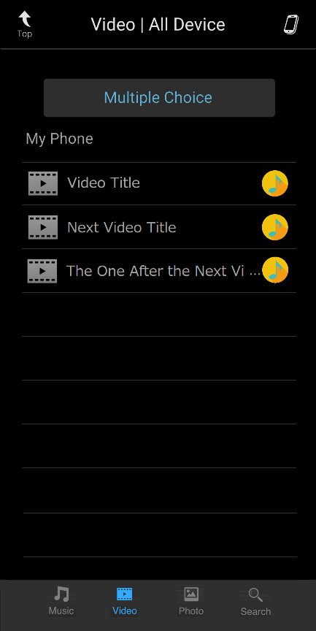

⑮

⑯

⑱

⑰

1. Playlist

*Displays a list of videos stored on the device.* *The icon on the right shows the device which owns the file. Select the list to play the video.*

1. Playing Time

*Displays the duration of the played video. Slide the bar to change the playback position.*

1. Repeat Play
2. [|<<] Return to the Beginning of Current Video
3. [ || ]/[ > ] Pause/Play
4. [>>|] Skip to the Next Video
5. Shuffle Play
6. Top Icon

*This icon is common to all content screens. The display shows the Video playback screen.*

1. Multiple Choice
2. Video List
3. Video Icon
4. Search Icon

### Playback

**1 Touch [Main Menu] icon on top.**

The display shows the Main Menu screen.

**2 Touch [Browse].**

The display shows the Browse screen.

**3 Touch [Video] icon on bottom.**

The display shows the video list screen.

**4 Touch [My Phone] button on video list screen.**

The display shows the locally stored video list screen.

The list is displayed in ascending alphanumeric order.

**5 Select the desired video from locally stored video list.**

The display shows the video playback screen.

**6 Touch [|<<] or [>>|] or select the desired video.**

***Returning to the beginning of the current video:***

Touch [|<<]

***Advancing to the beginning of the next video:***

Touch [>>|]

**7 To pause playback, touch [ || ] on bottom banner.**

Touch [>] of bottom banner to start playback.

### Repeat Play

**Touch [Repeat Play] icon on bottom to enable repeat playback.**

The videos will be played repeatedly.

The repeat mode switches every time the icon is touched.

Repeat List→Repeat One→ (Off) → Repeat List



### Shuffle Play

**Touch [Shuffle Play] icon on bottom banner during playback.**

The video shuffle randomly plays back video within a playlist.

The video within the playlist are played only once until all videos have been played.

Shffle → (Off) → Shuffle

### Share Content

You can only share to the devices you have set to share.

[See “Coose a device to Share”](#_Choose_a_device)

**1 Touch [Share] icon on playback screen during playback.**

The display shows the Content Share window.

**2 Select a device from Content Share window.**

*If the mark on the left side of the list becomes ☑ from □, it is selected properly.*

*If you want to stop sharing, tap (X) at the top of the screen.*

**3 Touch [Share] button on Content Share window.**

Select the sharing method.

* **Share One** : Share only one content that is playing.
* **Share List** : Share a list of the categories you're playing.

### Multiple Choice

You can select and play multiple contents categories.

**1 Touch [Main Menu] icon on top.**

The display shows the Main Menu screen.

**2 Touch [Browse].**

The display shows the Browse screen.

**3 Touch [Video] icon on bottom.**

The display shows the video list screen.

**4 Touch [My Phone] button on video list screen.**

The display shows the locally stored video list screen.

The list is displayed in ascending alphanumeric order.

**5 Touch [Multiple Choice].**

The display shows the [Play] and [Cancel] button.

**6 Select the desired video from the list.**

*If the mark on the left side of the list becomes (+), it is selected properly.*

**7 Touch [Play] button.**

The display shows the video playback screen.

*If you want to stop Multiple Choice, touch [Cancel] button.*

### Video Name Search

**■Search Screen**

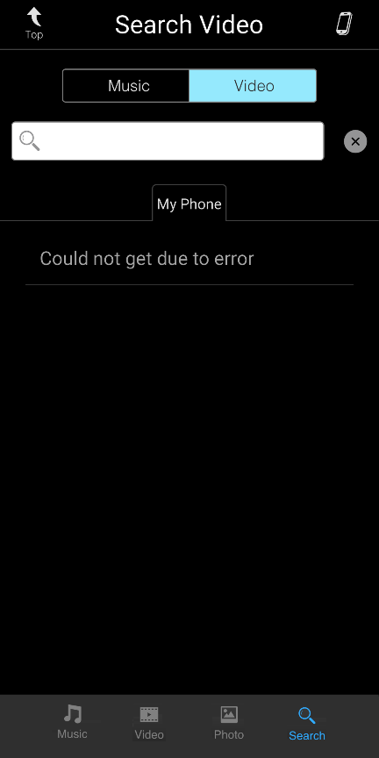

➀

②

③

④

⑤

1. [Video] Button
2. Free Word Search Bar
3. Category Tab
4. Search Result List
5. Search Icon

**1 Touch [Main Menu] icon on top.**

The display shows the Main Menu screen.

**2 Touch [Browse].**

The display shows the Browse screen.

**3 Touch [Search] icon on bottom.**

The display shows the Search screen.

**4 Touch [Video] button on Search screen.**

**5 Enter words to be searched in the bar.**

The display shows search result list.

**6 Select from the search result list.**

The display shows the video playback screen, Start playback the selected content.

## Photo \_\_\_\_\_\_\_\_\_\_\_\_\_\_\_\_\_\_

You can see photos of the connected device.

### ■Photo List Screen

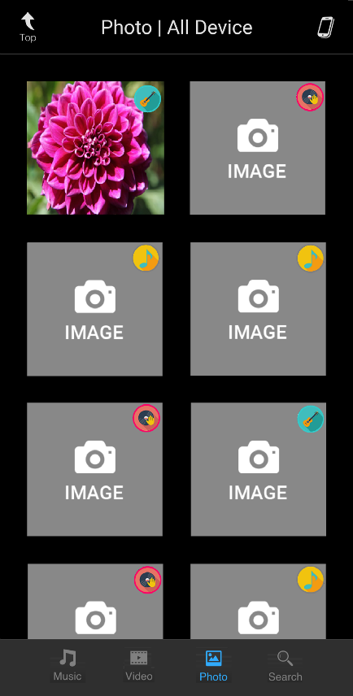

③

⑧

⑨

1. Top Icon

*This icon is common to all content screens. The display shows the music or video playback screen.* *Return to the content you were playing before you had selected to see a photo.*

1. Device List Icon

*This icon is common to all content screens. The display shows a list of connected devices. You can choose a device to which you would like to share the contents.*

1. Photo List

Tap the photo you want to see to zoom, switchs from the list screen to the full screen.

1. Switch from Full Screen to List Screen

*Touch to switch from the full screen to the list screen. When you want to switch from the list screen to the full screen, touch the photo you want to see.*

1. Photo View Screen
2. Switch to Previous Photo
3. Switch to Next Photo
4. Slide Show Button

*Touch to switch between start and stop the slide show.*

■Photo Full Screen

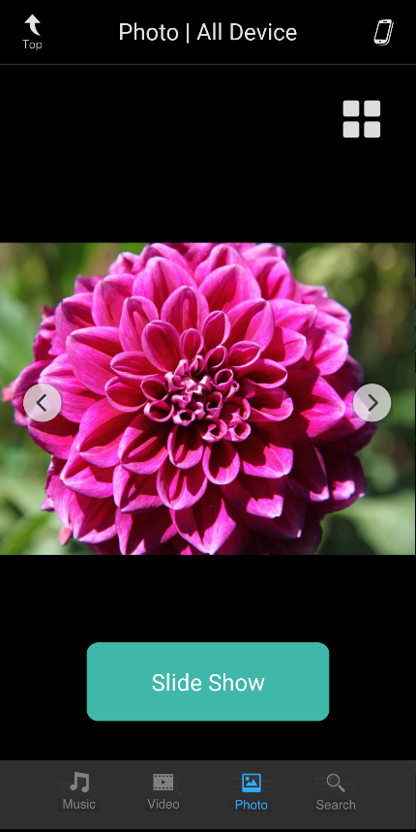

④

⑤

⑧

⑥

⑦

### See Photo

**1 Touch [Main Menu] icon on top.**

The display shows the Main Menu screen.

**2 Touch [Browse].**

The display shows the Browse screen.

**3 Touch [Photo] icon on bottom.**

The display shows the Photo list screen.

**4 Select Desired Photo.**

You can select a photo from the photo list screen.

The display switches from the list screen to the full screen.

**5 Touch [<] or [>].**

***Switch to the previous photo:*** Touch [<]

***Switch to the next photo:*** Touch [>]

### Slide Show

**Touch [Slide Show] button.**

Start a slide show on the full screen. Touch to switch between start and stop the slide show.

Slide Show Start → Slide Show Stop



## Settings \_\_\_\_\_\_\_\_\_\_\_\_\_\_\_\_

**Various preference can be set in Settings in the Main Menu.**

**Touch [Main Menu] icon on top left corner.**

*If [Main menu] icon is hidden, touch [Top] icon on top left corner of Browse screen (Music/Video playlist, Photo screen Search screen).* [*See “About Main Menu”*](#_About_Main_Menu)

**■Main Menu Screen**

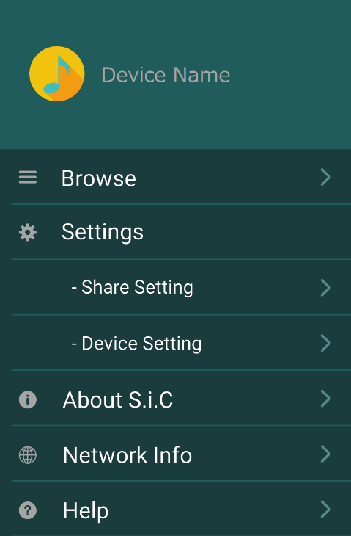

②

1. Share Setting
2. Device Setting

### Share Setting

**Touch [Share Setting] under Settings.**

Set contents sharing preference.

Even if you set to share, the contents shared will not be duplicated, edited or deleted by other accessing devices.

**■Share Setting Screen**

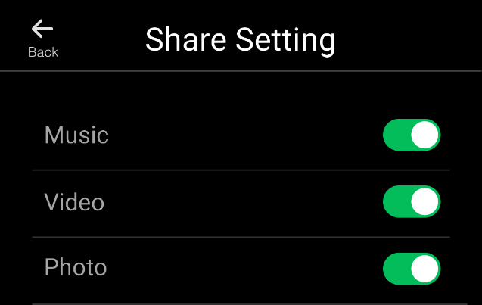

画像

画像Not Sharing (default): / Sharing:

* Music: Set to share or not share locally stored music.
* Video: Set to share or not share locally stored video.
* Photo: Set to share or not share locally stored photo.

### Device Setting

**Touch [Device Setting] on Main Menu.**

Register/edit the device name and device icon.

The registered device name and icon are shared between connected devices.

**■Device Setting Screen**

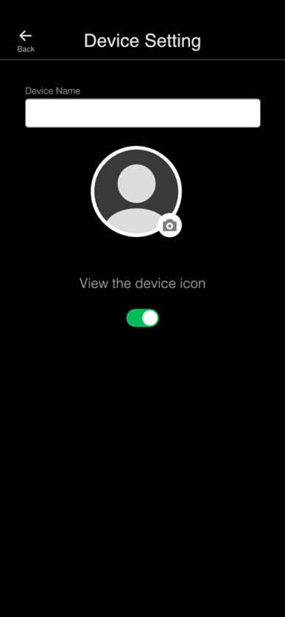

**■Icon setting screen**

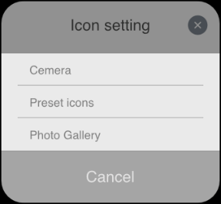

1. Device Name

Enter the device name in register/edit.

1. Device Icon

Touch to display the icon settings menu and register.

* Camera: Take a photo and register
* Preset Icons: Register from the included images
* Photo Gallery: Register from the photos gallery

1. View the Device Icon

画像画像

hide: / view:

INFORMATION\_\_\_\_\_\_\_\_\_\_\_\_\_\_\_\_\_\_\_\_\_\_\_\_\_\_\_\_\_\_\_\_\_\_\_\_\_\_\_\_\_\_\_\_\_\_\_\_\_

About Application

**■Application Info Screen**

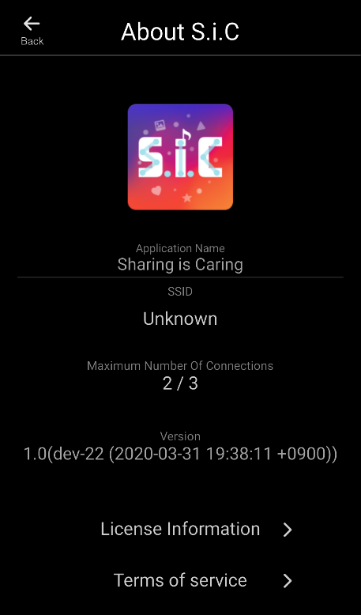

①

②

④

1. Application Icon

This application’s icon..

1. Application Name

Name of this Application..

1. SSID

Name of the Wi-Fi access point being used. .

1. Maximum Number Of Connections

Displays the number of connected devices.

Up to three devices can be connected.

1. Version

Software version of the Application.

1. License Information

Displays OSS license information.

1. Terms of Service

Display the Terms & Conditions of this Application.

FAQ (In Case of Difficulty)

### Can’t connect between devices

First, make sure you have a network environment.

There are several ways to create a network environment:

- Connect to Wi-Fi devices at home

- Connect to a public Wi-Fi

- Mobile router/ tethering (wireless connection)

Then check your settings.

- Make sure that the location information of the device is turned on.

- Make sure that your device's Wi-Fi communication is turned on.

- The devices you want to connect to are connected to the same Wi-Fi communication.

- Tap Application Info in the main menu to see the communication network with the SSID displayed on the screen.

- If the SSIDs are different between devices, try connecting to the same network again in your Wi-Fi settings.

If you don't see the SSID, you may not be granted application permissions.

- Make sure app permissions are granted.

See “Check the permissions for the application.”

If you are still unable to connect even if there is no mistake in the environment and settings, try the operation in order from 1 listed below, and complete the operation when the connection is complete.

1 Try to authorize the connection between devices.

[See " Establishing Connections Between Devices"](#_Establishing_Connections_Between)

2 Restart the app.

3 If you can't connect even after restarting the app, reinstall the app.

If you are unable to connect until the end, please contact us on the last page of this document.

### Can’t operate the application.

Please perform the force-quit of the Application.

If you still cannot operate even after the force-quit, restart the device.

### Can’t share content between devices

**Check the following settings:**

* Make sure Share Settings for the content you want to share are turned on. [See "Share setting"](#_Share_Setting)
* Make sure Share Setting with the device you want to share is turned on. [See "Choose a device to share"](#_Choose_a_device)

If you cannot share even if there is no mistake in the settings, restart the Application and reconnect each device.

### Can’t play content

Content that can be shared and played depends on your device and the file format of the content.

[See "Switching contents"](#_Switching_Contents)

### You want to revoke the app terms and conditions

Please uninstall this application by the operation of the device.

FAQ (If This Message Appears)

### Please check Wi-Fi connection.

Displays when Wi-Fi connection fails.

Check your network environment and settings.

[See "Can’t connect between devices "](#_When_the_Devices)

### Please restart the app.

Displays when the UPnP server media player fails to start. Please restart the app.

### Storage access is not permitted

Displays when this app does not have access to the storage in the device.Storage in the device refers to media files (music, videos) in the device.

You need to access media files and photos on your device to share content.

Select this app from the device settings menu "Apps and Notifications" and check and change the permissions to storage through "App Information" - "Permissions".

### Location access is not permitted

Displays when this app does not have right to access to device location information.The device location information is required to check the SSID of the Wi-Fi connection.

Select this app from the device settings menu "Apps and Notifications" and check and change the permission to location information through "App Information" - "Permissions".

### We could not get the playback time.

Displays when the playback time cannot be retrieved.

There is no workaround. (Notifications only).

### Playback failure:

Displays if playback fails.There is no workaround. (Notifications only).

The content that can be played depends on your device and the file format of the content. [*See "Switching contents"*](#_Switching_Contents)

### No results found

Displays when there is no applicable result. There is no workaround. (Notifications only).

### Device authentication could not be completed

Displays when your device is not authenticated and cannot be displayed in the list. The device is not connected.

[See " Establishing Connections Between Devices "](#_Authenticate_connections_between)

### Could not get due to Error

Displays when your device could not get the results due to a communication error. Check your network environment and try again.

### Failed to join network.

Displays when host authentication on the Main device fails.

Enter the correct host authentication code and try again.

### No content is available.

Displays when no content is selected. Select the content you want to play.

### IP address not obtained

Displays when IP address acquisition fails in the network connection immediately after this App starts. Try to connect to Wi-Fi in the device settings menu and then start the app.

### UPnP server failed to start

Displays when uPnP server startup fails with the network connection immediately after this App starts. Try to connect to Wi-Fi in the device settings menu and then start the app.

### Media server failed to start

If you try to start this app duplicateally, the media server is already started and displays "Media server startup failure".

### Media player failed to start

Displays when the media player fails to start. Try playing again or restart the app.

Notice of Support

For questions not addressed by this manual, please e-mail us at [support@the-sharing-is-caring.com](mailto:support@the-sharing-is-caring.com)